ASSIGNMENT 1

SYED IRTAZA AKRAM (SP23-BSE-151)

API CRUD OPERATIONS

GET OPERATION:

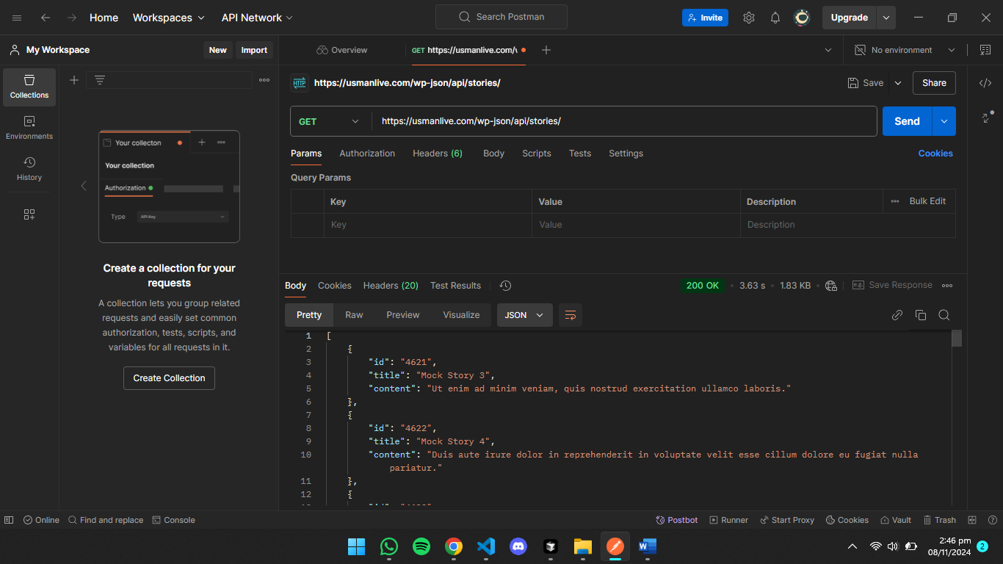

DELETE OPERATION:

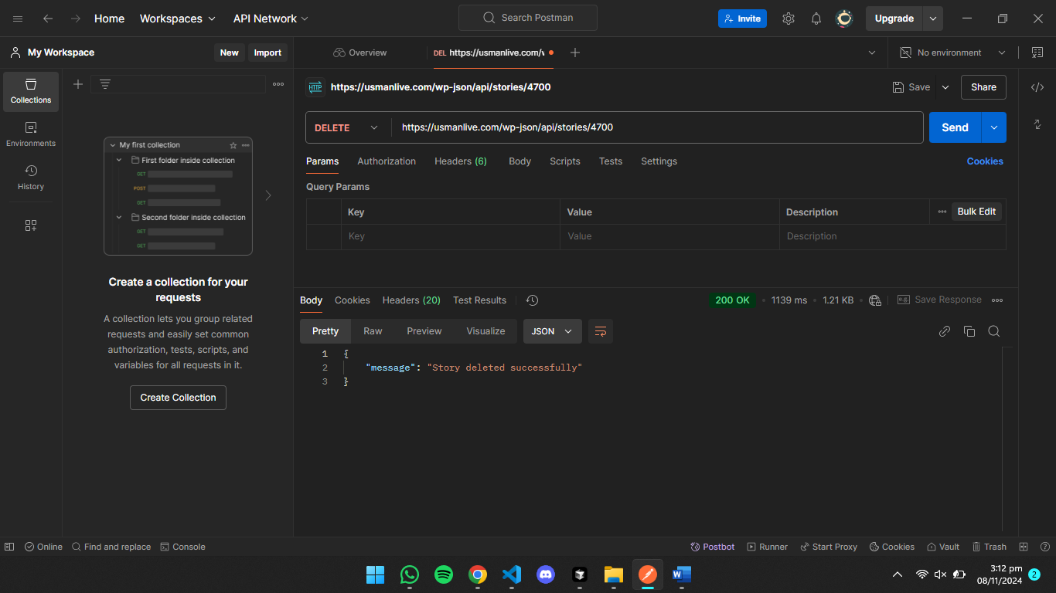

POST OPERATION:

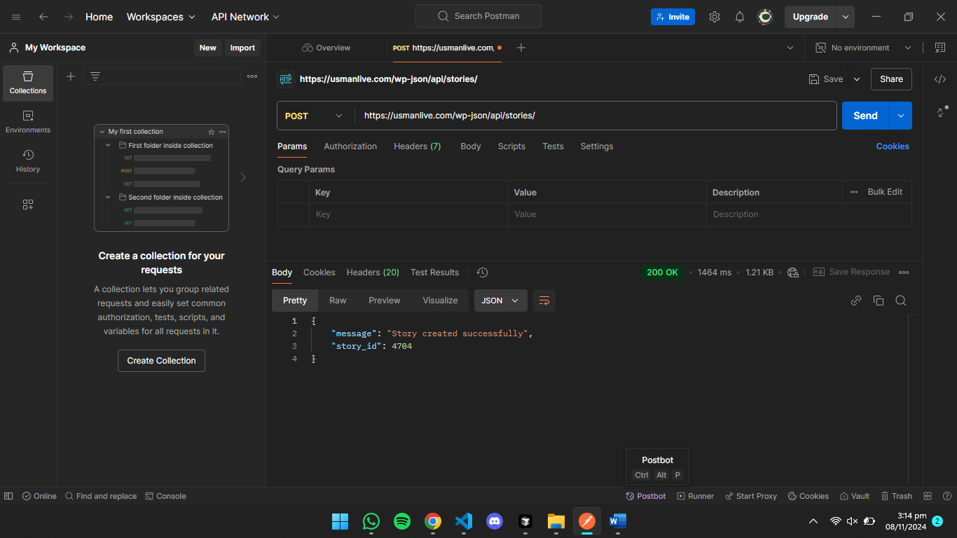

POST OPERATION:

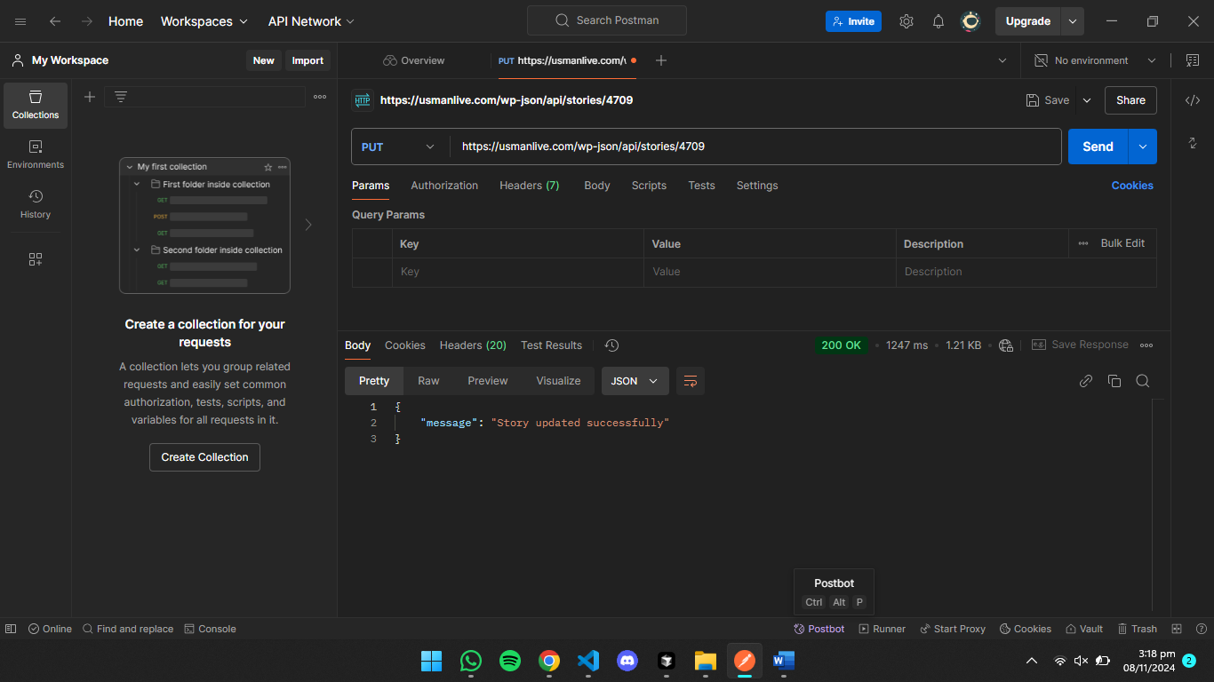

Frontend for stories hub:

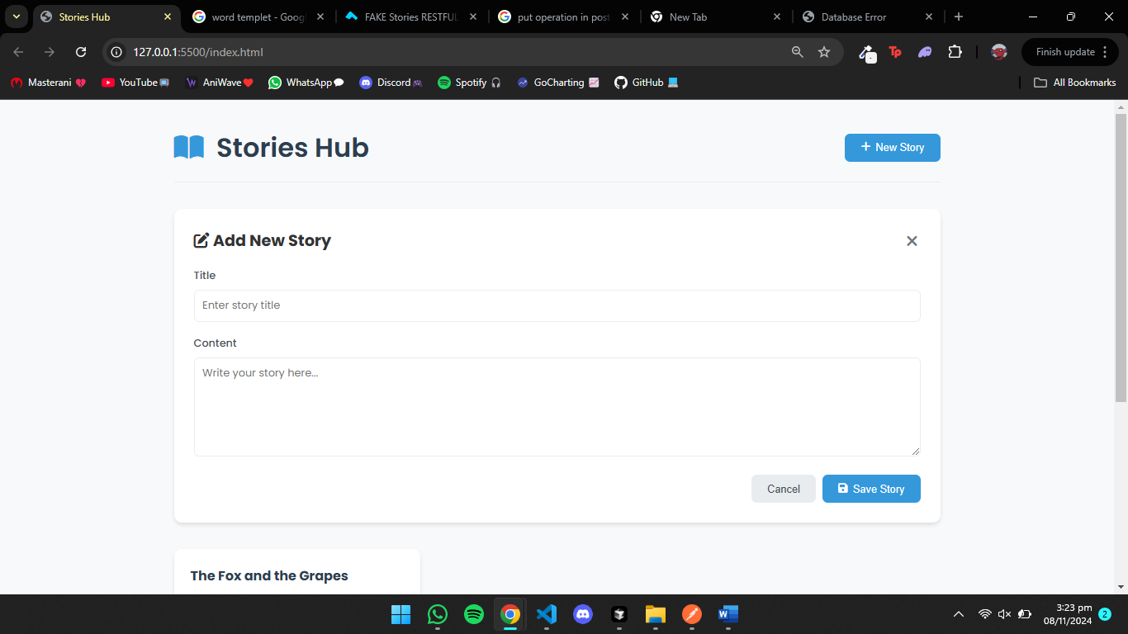

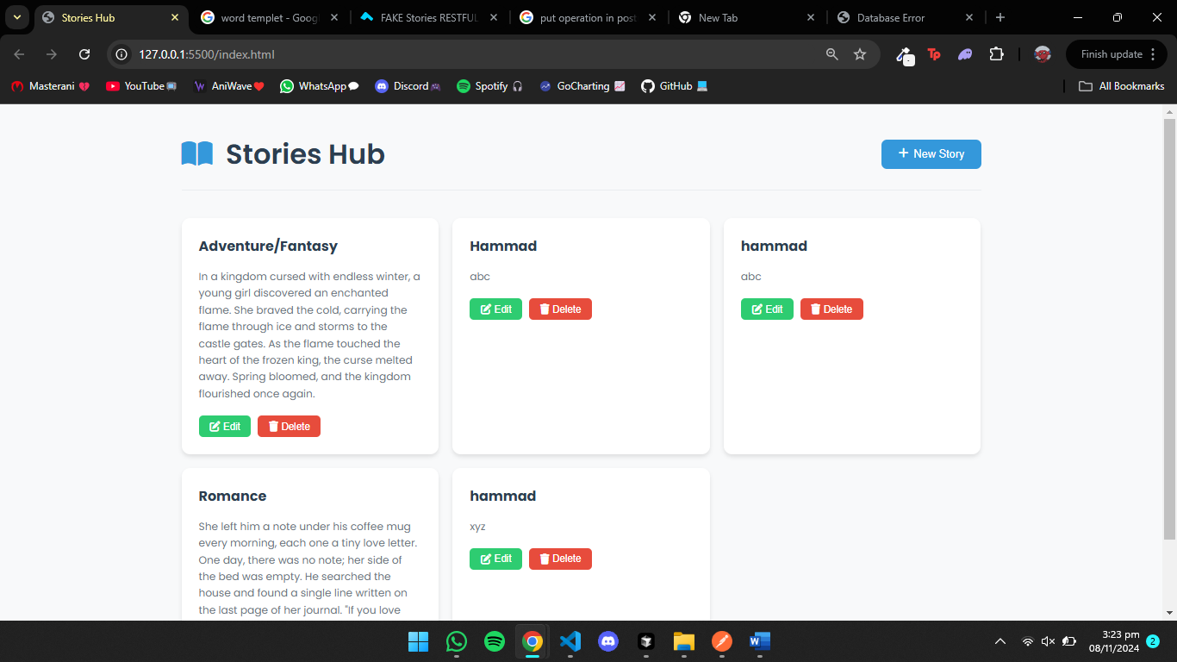

Files:

HTML: 

CSS: 

Javascript: 